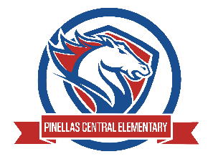

Pinellas Central Elementary School
Kindergarten School Supply List 2025-2026

Abby Cannata, Principal Stephanie Wager, Asst. Principal
- Student Items (for individual students use)
- plug-in headphones (no earbuds or Bluetooth)
- 1 student’s choice folder for take home folder (fun design or favorite color)
- full size backpack (no wheels)
- 1 hard plastic pencil box
- 1 primary journal/composition notebook (writing lines and space for drawing)
- Student Supplies (for classroom community use, please do not label)
- 4 plastic 2 pocket folders with prongs (1 red, 1 yellow, 1 green, and 1 blue)
- 2 boxes of crayons -16 count
- 6 glue sticks
- 2 boxes of yellow pencils
- 1 package pencil top erasers
- 2 dry erase markers
- Note: Please no special pencils (characters, glitter, designs, etc.) Only yellow #2 pencils will be used.
- Supplemental Classroom Items – Donations Appreciated
- tissues
- disinfecting wipes
- disinfecting spray
- hand sanitizer
- zip top plastic bags – sandwich or gallon size

